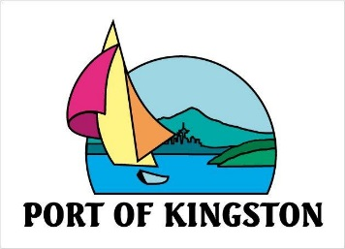
Port of Kingston Board of Commissioners
Special Meeting Minutes

10/02/2015 1:00 PM
Kingston Cove Yacht Club: 25878 Washington Blvd

Meeting called by: Port of Kingston Commissioners
Type of meeting; Special Meeting

Commissioners Present Staff Present
Commissioner, Bruce MacIntyre Executive Director, David Malone
Commissioner, Pete DeBoer Controller, Nancy Payne
Commissioner, Walt Elliott

- CALL TO ORDER
Chairman Bruce MacIntyre called the meeting to order at 1:00 p.m.

- APPROVAL OF AGENDA
Motion: Approve the agenda as written
Moved by: Commissioner, Walt Elliott
Seconded by: Commissioner, Pete DeBoer
Action: Passed 3-0

- EXECUTIVE SESSION: RCW 42.30.110
Chairman, Bruce MacIntyre announced the Executive Session for two hours at 1:01 p.m.
Chairman, Bruce MacIntyre announced the end of the Executive Session at 3:01 p.m.

- ACTION ITEMS

  - Resolution 10-01-2015 Employee Indemnification
Item tabled at this time for Commissioners to review language in RCW 53.08.208 and 53.08.205.
  - Such action(s) as necessary or appropriate concerning items discussed in Executive Session.
No items discussed.

- ADJOURN
Motion: Adjourn the meeting.
Moved by: Commissioner, Walt Elliott
Seconded by: Commissioner, Pete DeBoer
Action: Passed 3-0; meeting adjourned at 3:05 p.m.

Adopted in open session this _____ day ____________________________________
of October, 2015. Commissioner, Bruce MacIntyre

Attest:

________________________________ ____________________________________
Controller, Nancy Payne Commissioner, Walt Elliott

____________________________________
Commissioner, Pete DeBoer

